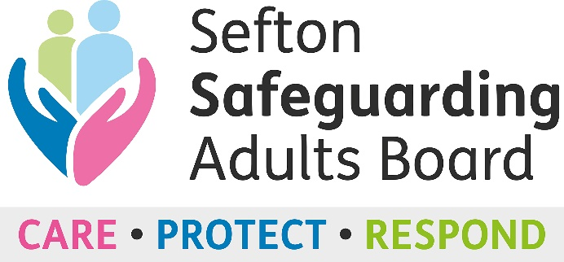

Safeguarding Adult Board L&D Sub-Group
Safeguarding Training Audit

Introduction

One of the actions in the Learning and Development Safeguarding Adults sub-group is to review the current training provision, delivery, and flexibility of delivery styles across each partner organisation.

We have produced an audit to identify what safeguarding training each partner is delivering including the level, aims and learning outcomes, delivery style and target audience. The data gathered will enable the sub-group to identify any duplication, opportunities to standardise safeguarding training (where possible) and any gaps in our current offers that need addressing.

The data will also be used to support the future development of a draft multi-agency training plan that considers lessons learnt from reviews and practice issues etc to prevent abuse and neglect.

Name of organisation:

Date:

Name of person completing this audit:

Role:

Email address:

Organisation structure. Please tick one answer:

- Private
- Public
- Voluntary, community and Faith

Questions

- Does your organisation access Adult Safeguarding Training? Please tick one answer:

Yes
No

If yes, please provide details below:

Name of course | Level of course | Aims and Learning Outcomes | Frequency of training e.g. annual, three yearly etc. | Is the course Mandatory?  Y/N | How is it delivered e.g. eLearning, Classroom, Virtual Classroom etc. | Developed in-house or externally purchased? If purchased, please provide the training provider name and details | Cost and how it’s funded | Target audience e.g. front-line staff, team managers, senior managers etc. | Is the training for staff, volunteers or both?

- Does your organisation offer out/or is prepared to offer out places on your training and if so, would there be a charge? Please tick all that apply:

Yes – offer out places, no charge
Yes – offer out places but at a cost to the organisation
No

If you’ve answered yes to first two questions, provide a list of the training courses and costs below (if applicable)

Course title | Level of course | Can offer places, no charge (Yes/No) | Can offer places but at a cost to the organisation (Yes/No)

- Does your organisation access any other specialist or targeted Safeguarding Adult Courses that you have not included in Q1 e.g., self-harm, suicide prevention etc. Please tick one answer:

Yes
No

If yes, please provide details below

- Did you your organisation use a National Competency Safeguarding Framework to inform the development of your training for example, the use of a framework that refers to a combination of skills, knowledge and experience expected of individual staff to ensure high quality safeguarding practice. Please tick one answer:

Yes
No

If yes, tell us what framework you used and supply a copy if possible.

- Does your organisation have a Safeguarding Adults policy? Please tick one answer:

Yes
No

- If yes, how often does your organisation review the policy AND does your Safeguarding Adults policy inform on training requirements?

Frequency of Reviews (enter number here)

Does your policy inform on training requirements? Please tick one answer:

Yes
No

- Does your organisation have a designated Safeguarding Lead? Please tick one answer:

Yes
No

- Does your organisation know how to access the online Safeguarding Adults ‘Professional Referral’ form to report a Safeguarding concern? Please tick one answer:

Yes
No

- If yes, has your organisation used the online Safeguarding Adults ‘Professional Referral’ form? Please tick one answer:

Yes
No

- If yes, use the space below to tell us about your experience using the Safeguarding Adults ‘Professional Referral’ form including any suggestions for improvement.

- Use the space below to provide any additional comments or feedback regarding Safeguarding Adults training, policy, or anything else you feel would be of benefit to the work of the Safeguarding Adults L&D Sub-group.

Thank you for taking the time to complete the Safeguarding Training Adult
Please return completed questionnaires to Hannah Neary, Safeguarding Adults Board Support Officer at
Hannah.Neary@Sefton.gov.uk

