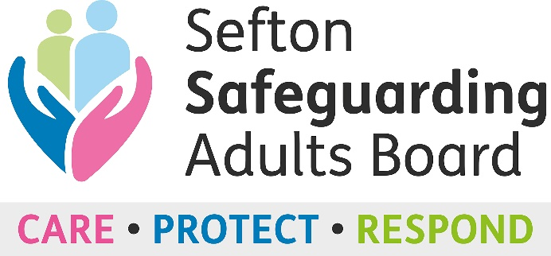
Safeguarding Adult Board L&D Sub-Group
Safeguarding Training Audit

Introduction

Sefton Safeguarding Adults Board are currently researching training and support for voluntary, community and faith sector groups to better understand the needs of small, medium and large groups who have a responsibility to safeguard vulnerable adults coming into contact with their services.

This piece of work is overseen by the Learning and Development Sub-group, of the Sefton Adult Safeguarding Board. The data will be used to support the future development of a draft multi-agency training plan that considers lessons learnt from reviews and practice issues etc to prevent abuse and neglect.

The survey should take no longer than 5 minutes to complete and your support is appreciated.

Name of organisation:

Date:

Name of person completing this audit:

Role:

Email address:

Questions

- Does your organisation access Adult Safeguarding Training? Please tick one answer:

Yes
No

If yes, please answer the following questions:

- Tell us what safeguarding training you provide to staff:

Course name | Delivered in-house or by an external training provider? Tick one option |  | How often is the training refreshed?
 | In-house | External training provider

- Tell us what safeguarding training you provide to managers:

Course name | Delivered in-house or by an external training provider? Tick one option |  | How often is the training refreshed?
 | In-house | External training provider

- Tell us what safeguarding training you provide to volunteers:

Course name | Delivered in-house or by an external training provider? Tick one option |  | How often is the training refreshed?
 | In-house | External training provider

- Does your organisation have a Safeguarding Adults policy? Please tick one answer:

Yes
No

- If yes, how often is your Safeguarding Adults Policy reviewed?

- Does your organisation have a designated Safeguarding Lead or Designated Safeguarding Officer? Please tick one answer:

Yes
No

- Does your organisation know how to access the online Safeguarding Adults ‘Professional Referral’ form to report a Safeguarding concern? Please tick one answer:

Yes
No

- If yes, has your organisation used the online Safeguarding Adults ‘Professional Referral’ form? Please tick one answer:

Yes
No

- If yes, use the space below to tell us about your experience using the Safeguarding Adults ‘Professional Referral’ form including any suggestions for improvement.

- Use the space below to provide any additional comments or feedback regarding Safeguarding Adults training, policy, or anything else you feel would be of beneficial to supporting your organisation with Safeguarding practice.

Thank you for taking the time to complete the Safeguarding Training Adult
Please return completed questionnaires to Hannah Neary, Safeguarding Adults Board Support Officer at
Hannah.Neary@Sefton.gov.uk

