ECM Forum Meeting

Thursday 24 June 2021

Welcome and Introductions
Sharon Cotterall (Children and Families Development Officer – Sefton CVS) welcomed the attendees and all introduced themselves.

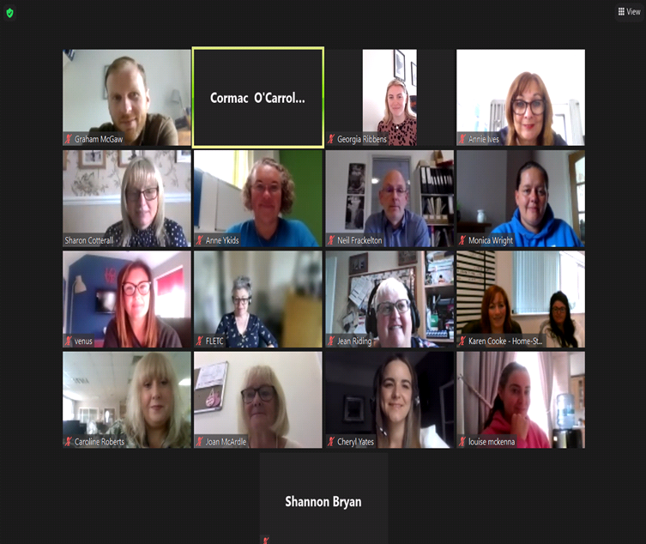

Children and Young People’s Partnership Board and Sefton’s Children and Young People’s Plan – Sharon Cotterall Sefton CVS

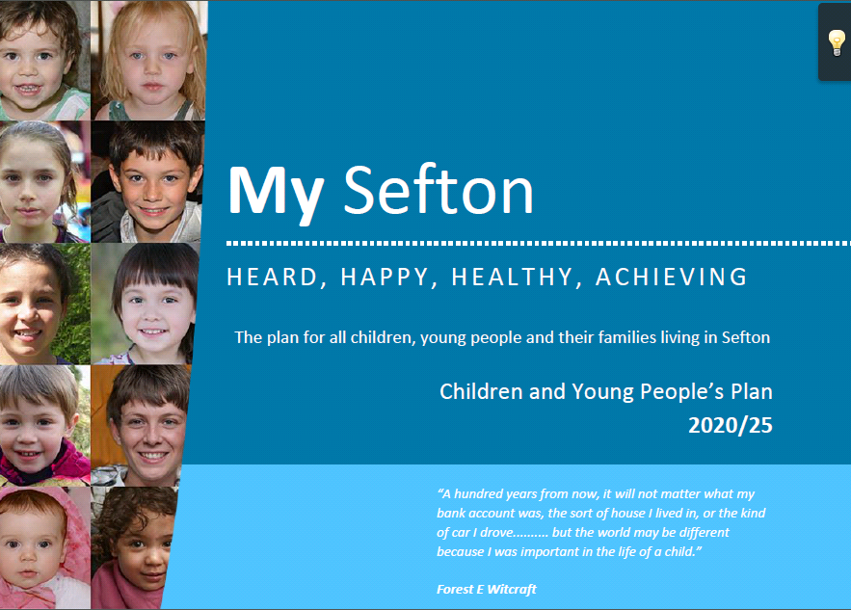

See link to the Power Point Presentation

See to Sefton’s Children and Young People’s Plan
https://seftonlscb.org.uk/lscb/news/children-young-people-plan-2020-25-sefton

Workshop – Break Out Rooms

How We Report Our Success and How We Improve for the Future – Sharon Cotterall Sefton CVS

Members were split into two break out rooms and discussions took place about how agencies record information and could share their information without creating more work when time is already short.
Suggestions - How?
- Huddle – soft ware that lets you upload your info
- Newsletters being shared with CVS
- A Rota for sharing info e.g. having certain groups sending a headline in for one of the four topics bi-monthly
- Google info sharing platform
- Emailing Sharon
- Using existing reporting systems to take info from and share
- Would find it useful if there was a way of merging some reporting together as it feels that there are a lot of things to report on. Such as copying people into emails etc.
- A directory of phone numbers/emails to link groups in together
- Having a live network to share work
Suggestions - What?
- Hard hitting information
- The risk we face in our work
- Celebrating the work done rather than it just being reported on
Questions Raised
- How does reporting this benefit the sector
- What happens to the information who else does it benefit?
- How often will we report in future?
- Why do we have to report when we do not receive funding?
- What value does this give us?
Sharon agreed to take this information and discuss with Nigel Bellamy.

Thrive Network Update – Sharon Cotterall
Sharon updated members. The first meeting took place on Tue 17 June 21 and was attended by 14 members. The training session was shared and members can book this free for their agency. Thrive Grant Application form was also shared.

CWAN Network – Sharon Cotterall CVS
Emma Lambert is off sick so the recent CWAN had to be cancelled. When Emma returns this will resume.

Members Information Sharing
Homestart Southport and Formby – Annie Ives
Home visits have now resumed and a Family Support Worker has been recruited. There is Adults Counselling for parents, Tidlers Group (for babies born in lockdown) and Toddler’s Group for 2 to 4 year olds alongside the usual offer through volunteers.

SWACA – Neil Frackleton
Child on Parent Violence Work – 2 staff one that works with parent predominantly Mum and one to focus on the child who is causing the harm (perpetrator behavior). They are also starting a male victim service. Neil reported a significant increase in risk around Domestic Abuse and a rise in Domestic Homicide.

We Are With You – Graham McGaw
Graham introduced himself to the members; he has replaced Rachel Hardy at We Are With You as Manager of the Young People and Families Substance Misuse Service. Graham is keen to link in with members and look at collaboration where possible.

Venus – Leanne Dowler
Venus have seen a huge impact on mental health on the return to school for children seeing high levels of anxiety. Leanne is part of the MHST (Mental Health Support Team) and will be based in The Thornton Centre. They will provide low level intervention and prevention work. At Venus they also have; CBT Therapist, Primary School Work with Parents, Alderhey Face to Face work, Star Centre, Parenting Group and Incredible Years. Other services and info available see Venus website.

Next ECM Meeting – Friday 10 September 21 Theme TBC

