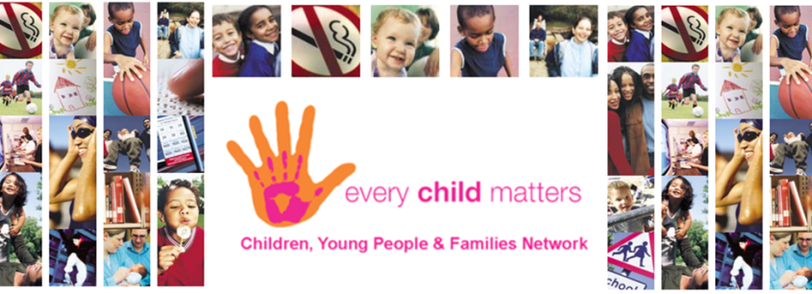
ECM Forum Meeting

Friday 3 December 2021

Welcome and Introductions
Sharon Cotterall (Children and Families Development Officer – Sefton CVS) welcomed the attendees and all introduced themselves.

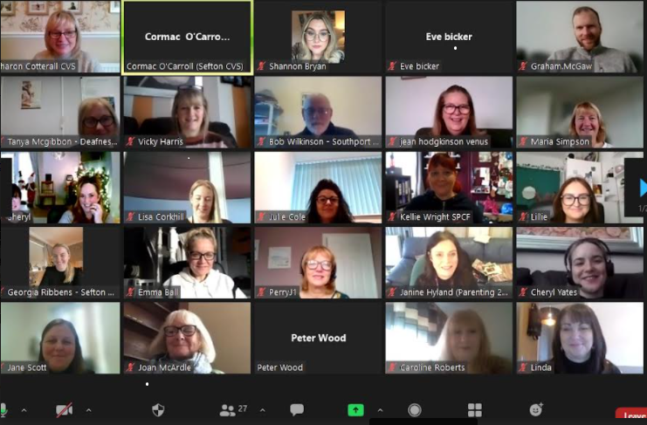

Alchemy Youth Detached – Parenting 2000
Janine Hyland (CEO) delivered a presentation see attached slides

Youth Voice Development – Sefton Young Advisors
Georgia Ribbens (Young Advisor’s Lead) and Rachel Bebby (Young Advisor) delivered a presentation see attached slides

Child on Parent Violence Work – SWACA
Jane Scott (Child on Parent Violence and Abuse Children and Young Persons Worker) delivered a presentation see attached slides

Alchemy Buddy Up + – Buddy Up

Emma Lambert (Sefton CVS) updated the forum about the pilot. Buddy Up and Alchemy are working in partnership to offer a new social club for young adults aged 18 to 25 who have mild to moderate additional needs and disabilities. There will be taster sessions on Monday 13th December from 6pm to 8pm at Alchemy, Mornington Road, Southport and Tuesday 14th December from 6.30pm to 8pm at Alchemy, Coronation Road, Crosby for young adults to attend with their parent carers or support workers to find out more about the social clubs and sign up to attend when they begin in January 2022.

It’s Not Me It’s You – RASA
Lorraine Wood (CEO) delivered a presentation see attached slides

Thrive Network Update – Sharon Cotterall
Sharon updated members. The next meeting is on Tue 14 December at 10.30am. The training session information was shared and members can book this free for their agency. A number of agencies have already booked this. Thrive Grant information was also shared.

Thrive Dates for 2022

CWAN Network – Emma Lambert CVS
Emma Lambert is catching up after being on long period of sick leave information will be sent out when next CWAN is arranged.

Tell Us – Merseyside Police
Lisa Corkhill (Intelligence Partnership Co-ordinator) shared information see attached.

Sefton Carers Centre – Eve Bicker
Eve updated members about a new set of books that they have for schools. They are local stories relating to the Sefton area and the idea is that they will help to identify Young Carers in school.

The Samaritans – Bob Wilkinson
Bob updated the members about resources that they have available see attached.

Next ECM is Wed 2 March 2022 – Theme to be confirmed

