 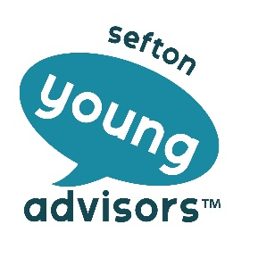

Young Advisors – Guidance for Completing Application Forms

Thank you for your interest in Sefton Young Advisors.

With this guidance you will find:

1. An application form
2. A job description which also includes skills needed for the role
3. And an equal opportunities monitoring form which you need to complete and return with your application form.

* Please make sure that you fill in all sections of the form.
* The job description tells you about the type of work you will have to do if you get the job. The ‘skills you need for the role’ section at the bottom of the job description tells you the skills you need for the job.
* This means that we will ask you questions on the application form or at interview to find out about those skills, so you need to think about how you could tell us that you have those skills.
* Try to express yourself as clearly as possible. This doesn’t mean we’re looking for perfect English or grammar – we just want to know you have a passion for youth voice.
* After the closing date for the application forms, the interview panel will meet and make a shortlist of people to invite to a group session. This helps us to make a decision about who has the right skills for the job and who we will invite to interview.
* After the group session, if you get an interview we will email or phone you and let you know. Please give us as many ways to contact you as possible on your application form.
* We will also ask you if you have any support needs that we may need to help you with at the interview or group session. Please tell us if you do; we want to help you, not exclude you.
* There will be no more than 3 people on the interview panel and we will give you the questions before the interview so that you can have a read and think about your answers. We understand that you may be nervous at interviews and forget what you want to say. You can make notes to help you.
* At the interview, the panel will ask you questions and we will make notes to help us remember what you said.
* If you are successful, we will telephone you and also put the offer into writing via email.
* If you are not successful we will email you.
* If you are not successful at interview you can contact Georgia via email georgia.ribbens@seftoncvs.org.uk. She will be happy to provide feedback.

*Good Luck…we look forward to receiving your application form!!*