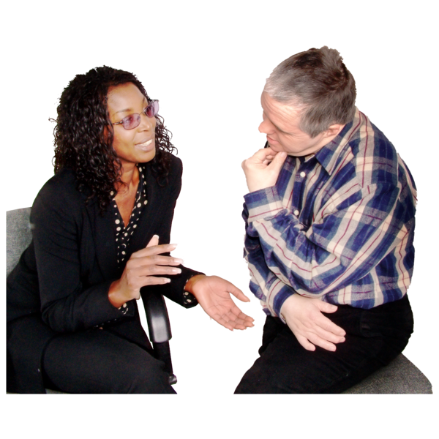 | What is the big conversation?  The big conversation is a project about adult social care in England.
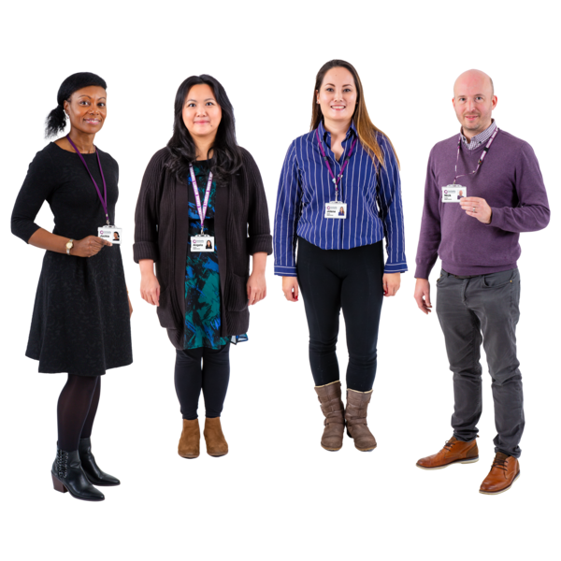 | The project is being run by the Independent Commission on Adult Social Care.  It is sometimes called the Casey Commission.
 | You can find out more about the Casey Commission on their website.
 | The project wants to know how make social care better.
 | We want as many people as possible to take part.
 | People can take part online.  We will also talk to people who have experience of using social care.  We will talk to people that work in care too.
 | What you tell us will help us talk to a group called the Public Panel on Care.
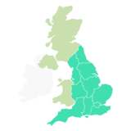 | The Public Panel on Care are a group of all sorts of different people from England.  
 | The Casey Commission are working with a company called Ipsos.  Ipsos are a research company. They talk to the public about things that are happening and listen to what they think.
 | How can I take part?  You can take part online. Go to the link below, the website is made by Make.org.
 | You will be asked a question at the start.  The question is: When we are old, disabled or have a serious illness, who should support us and how
 | When you have answered the question, you can share your own ideas.
   | You can also see other people’s ideas and say if you think they are good or bad.  You can talk about what support you need and how you like to get support.
 | Talking to lots of people will help us work out what things are most important about social care.  And we can work out what things people are worried about.
 | Why should I take part?  You can help us make social care work better.
 | You do not have to know anything about adult social care.  We just want to hear your ideas.
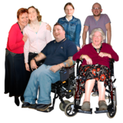 | We want to hear about adult social care from lots of different people you might:  - Use adult social care
 | - Work in care
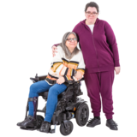 | - Care for a family member or friend
 | You might just want to share how you or a loved one would want care in the future.
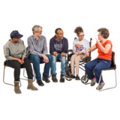 | How will we hear from people who might find it harder to take part?  We will work with trusted community groups, charities and care companies.  They might talk to people in groups or by themselves so they can have their say.

